**TRUENAS DISK PARTITION ON WINDOWS**

STEP-1

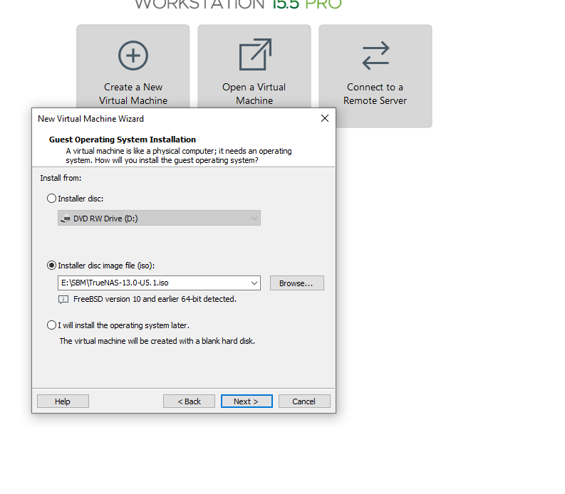

STEP-2 🡺 50 GB hard disk

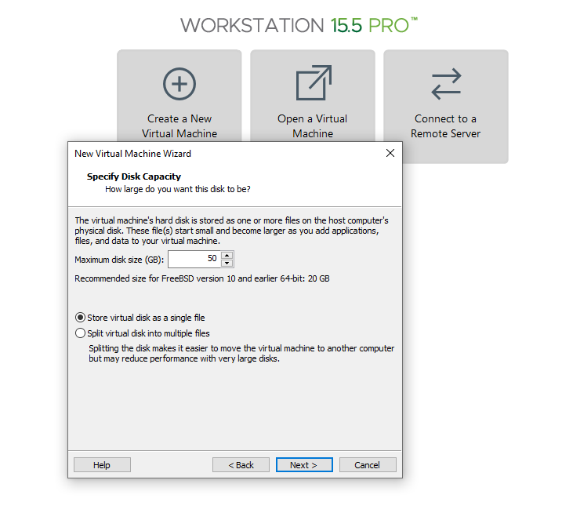

STEP-3 => 8GB Ram and 4GB processor and add 20 GB hdd four times

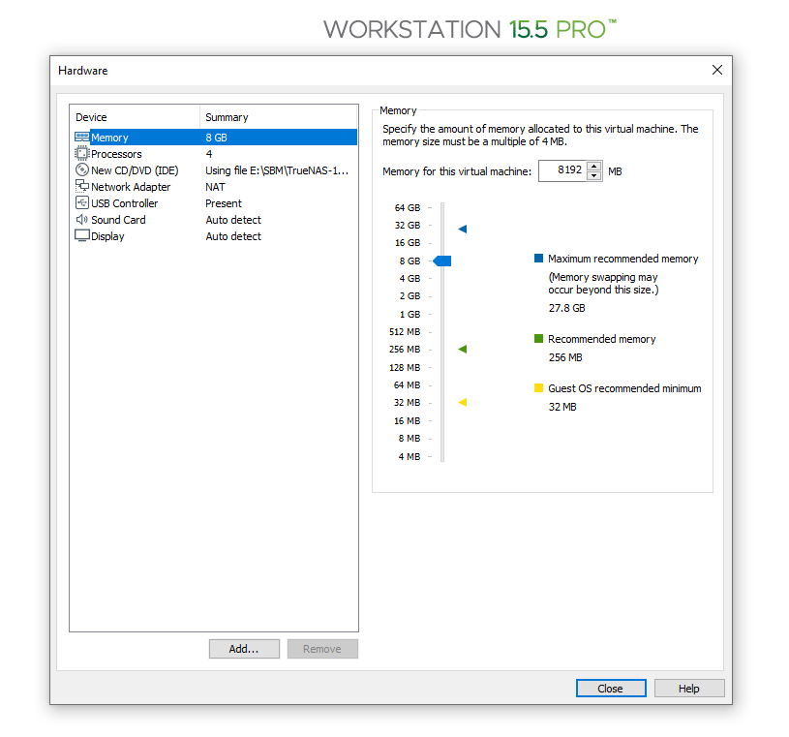

STEP-4 => power on the machine

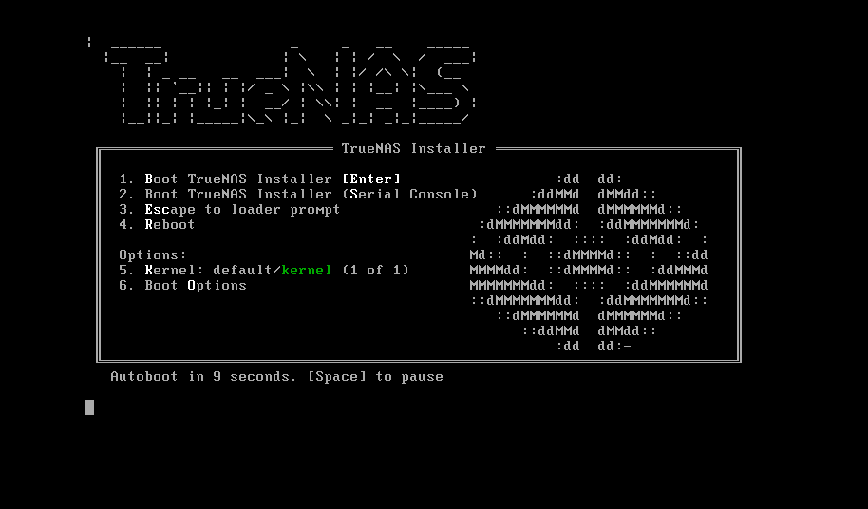

STEP-5 => Enter

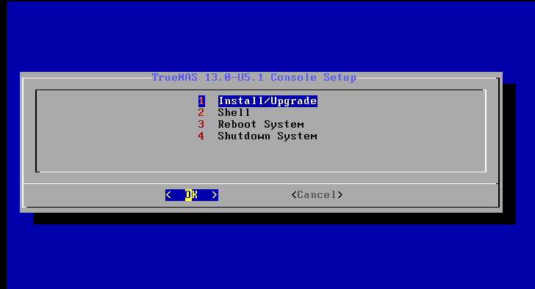

STEP-6 🡺 click on spacebar button and than Enter

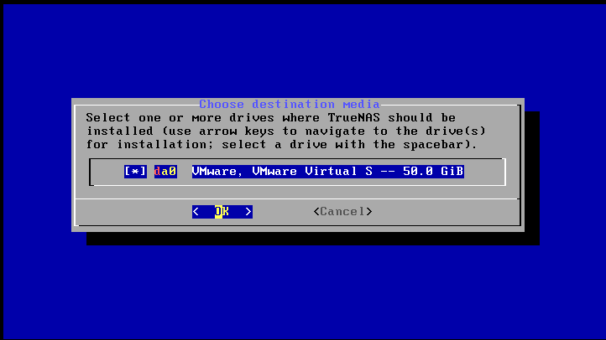

STEP-7

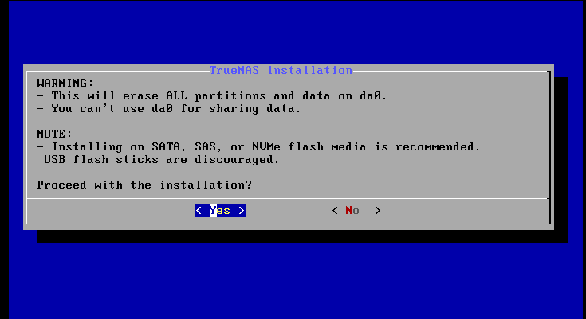

STEP-8 🡺 click on Boot via BIOS

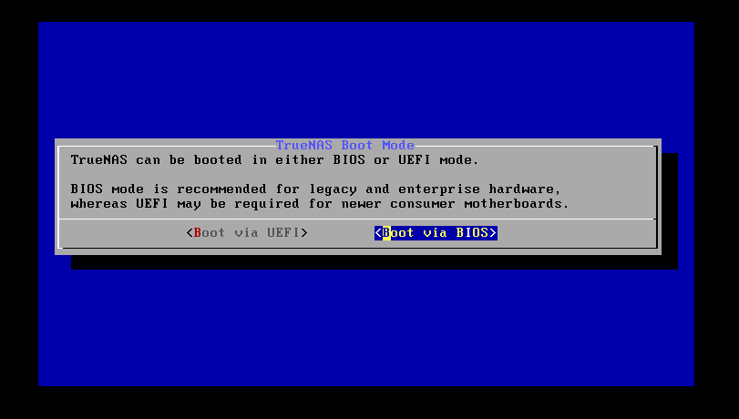

STEP-9

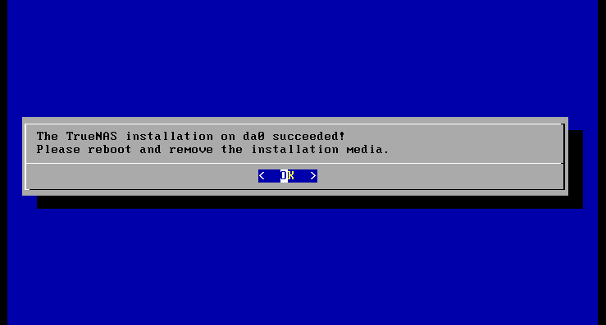

STEP-10 🡺 Select Reboot system and Enter

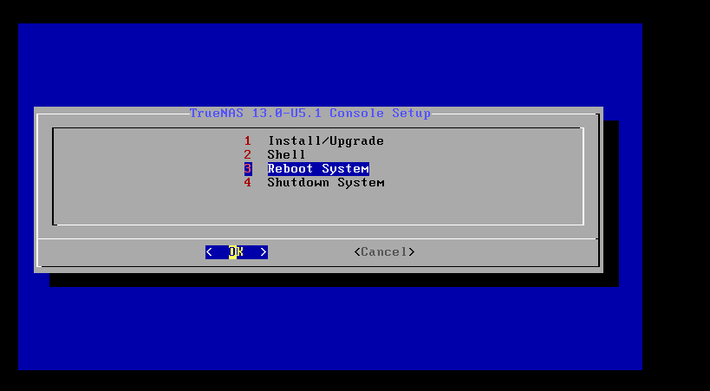

STEP-11 🡺 use the given IP and search on google

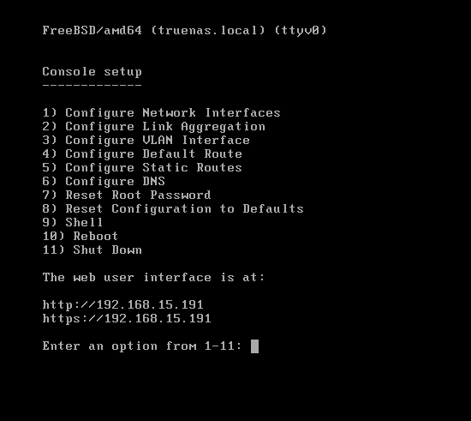

STEP-12 🡺 username – root

Password - root

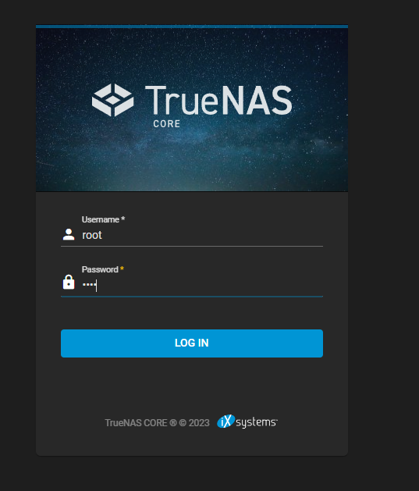

STEP-13 🡺 Go to storage 🡪 pool 🡪 name (hpcsa) 🡪 click on suggest layout and select all the disk

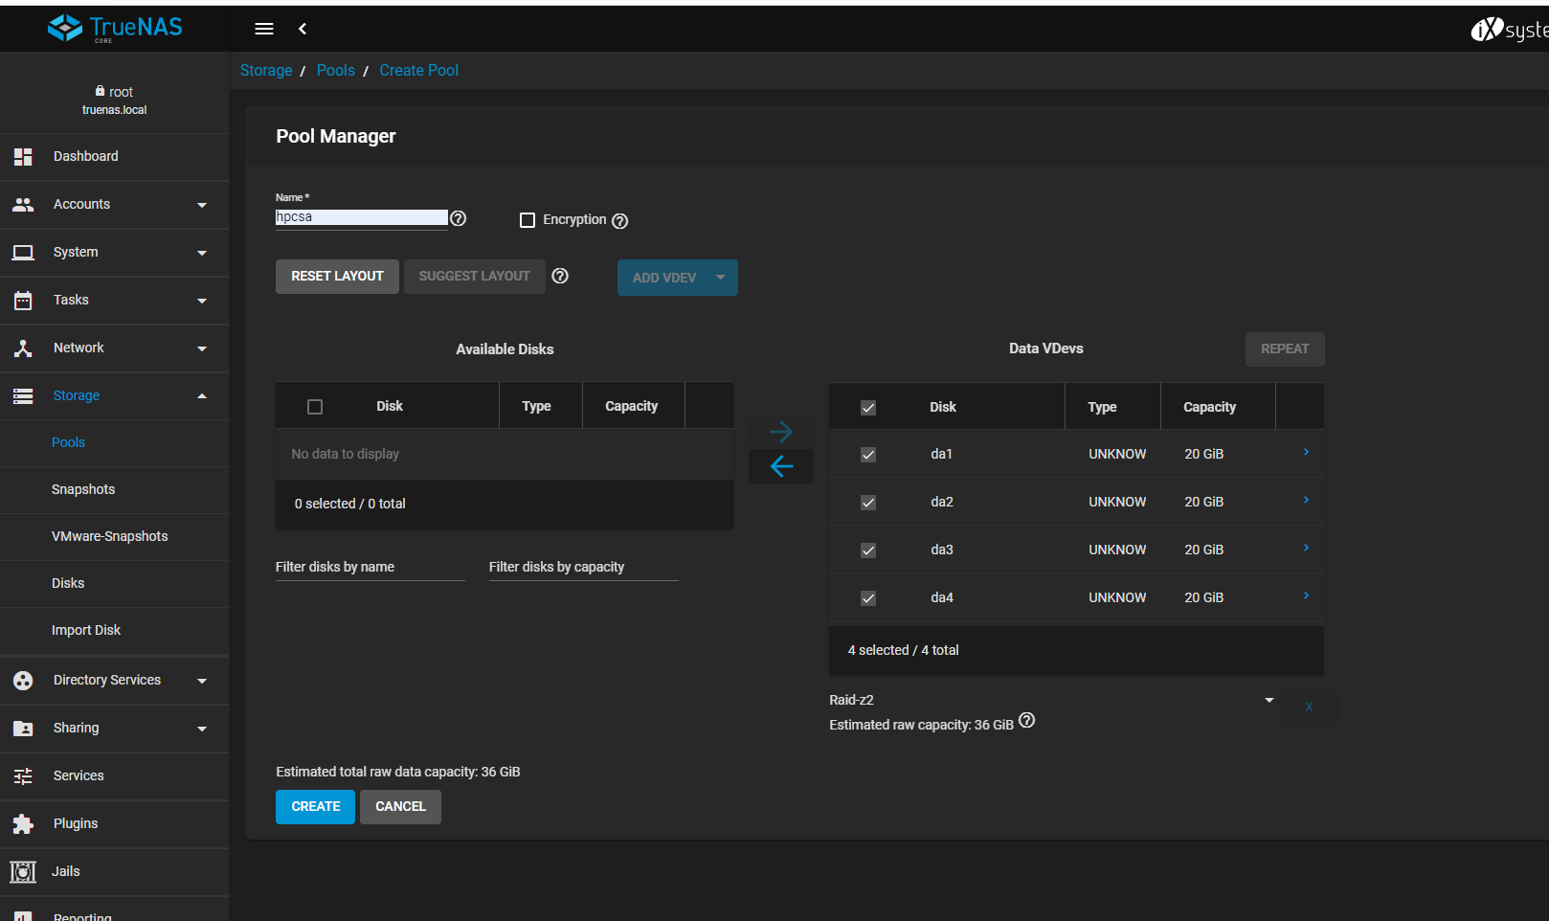

STEP-14 🡺 click on create

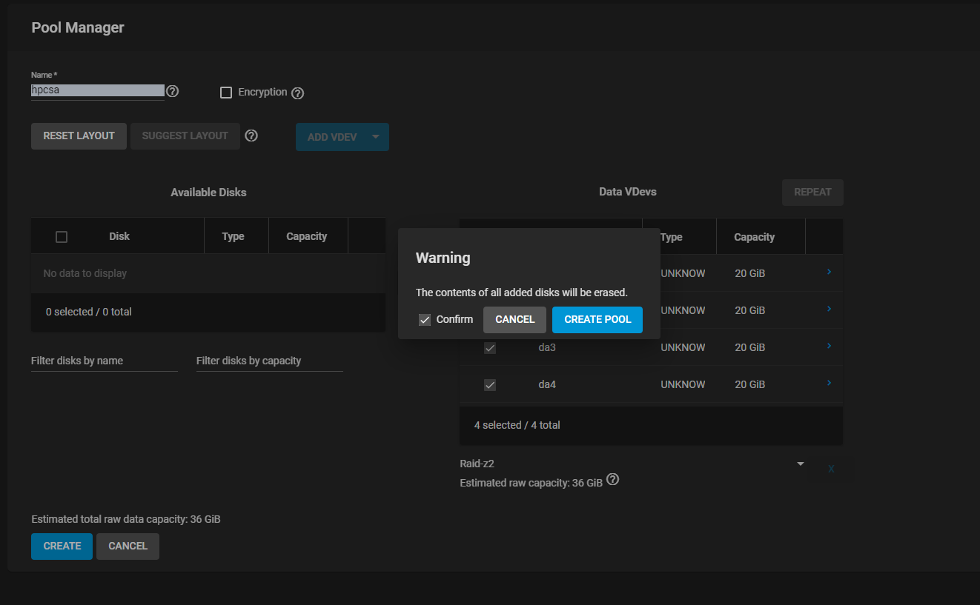

STEP-15 🡺 go to storage 🡪 pools

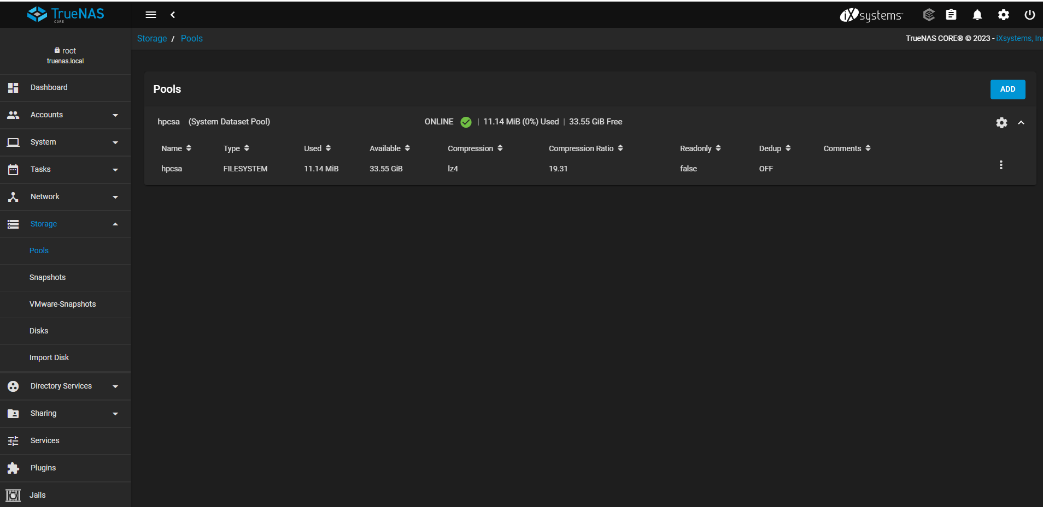

STEP-16 🡺 go to accounts 🡪 users

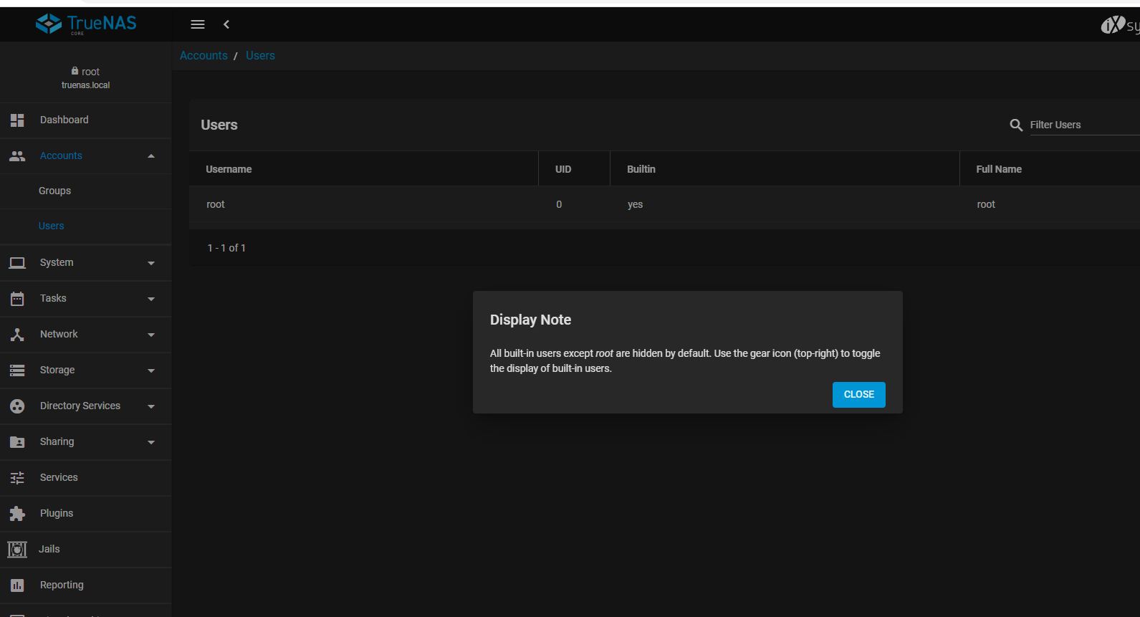

STEP-17 🡺 go to accounts 🡪 users 🡪 add

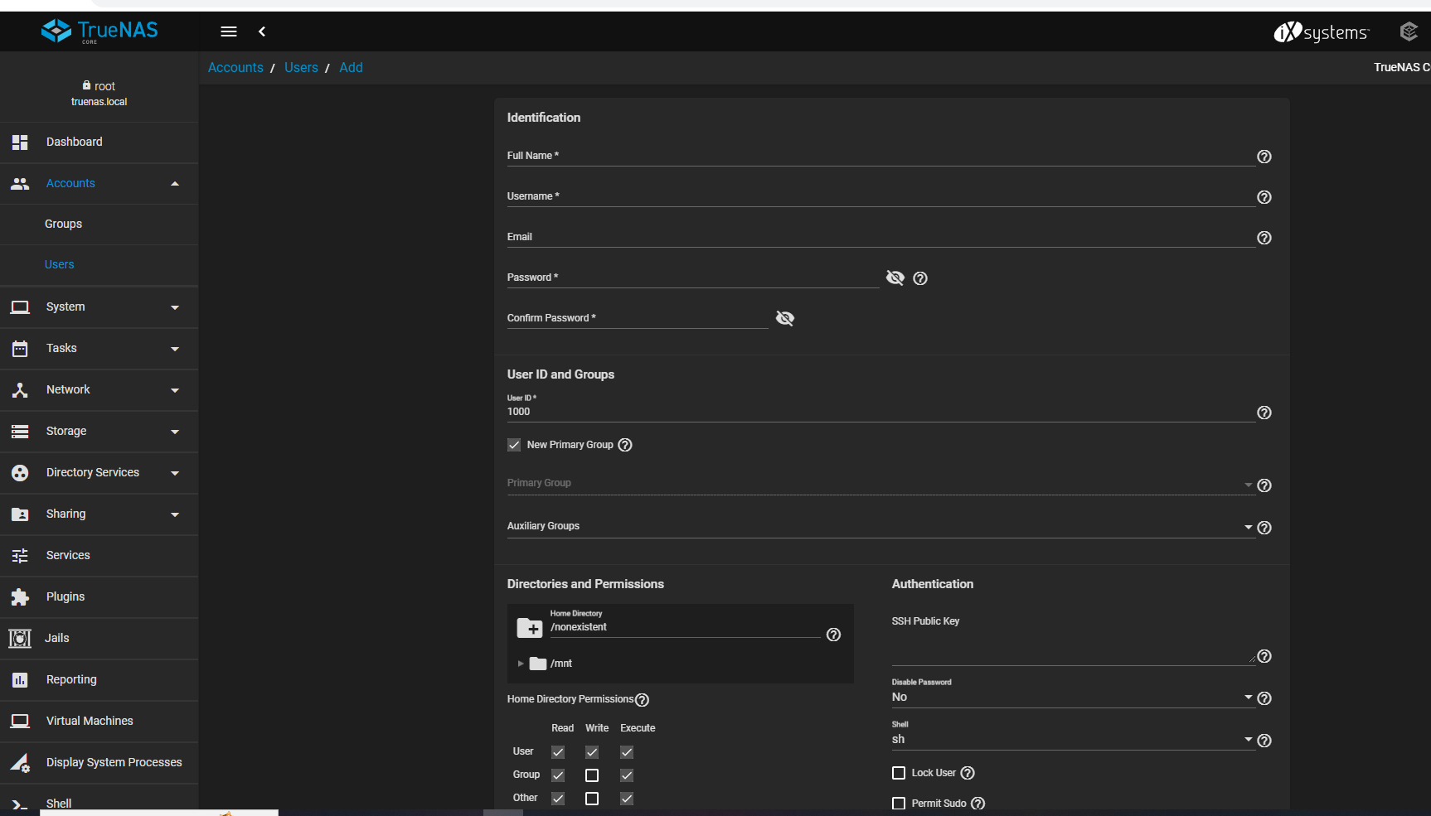

STEP-18 🡺 Enter the full name , username , password

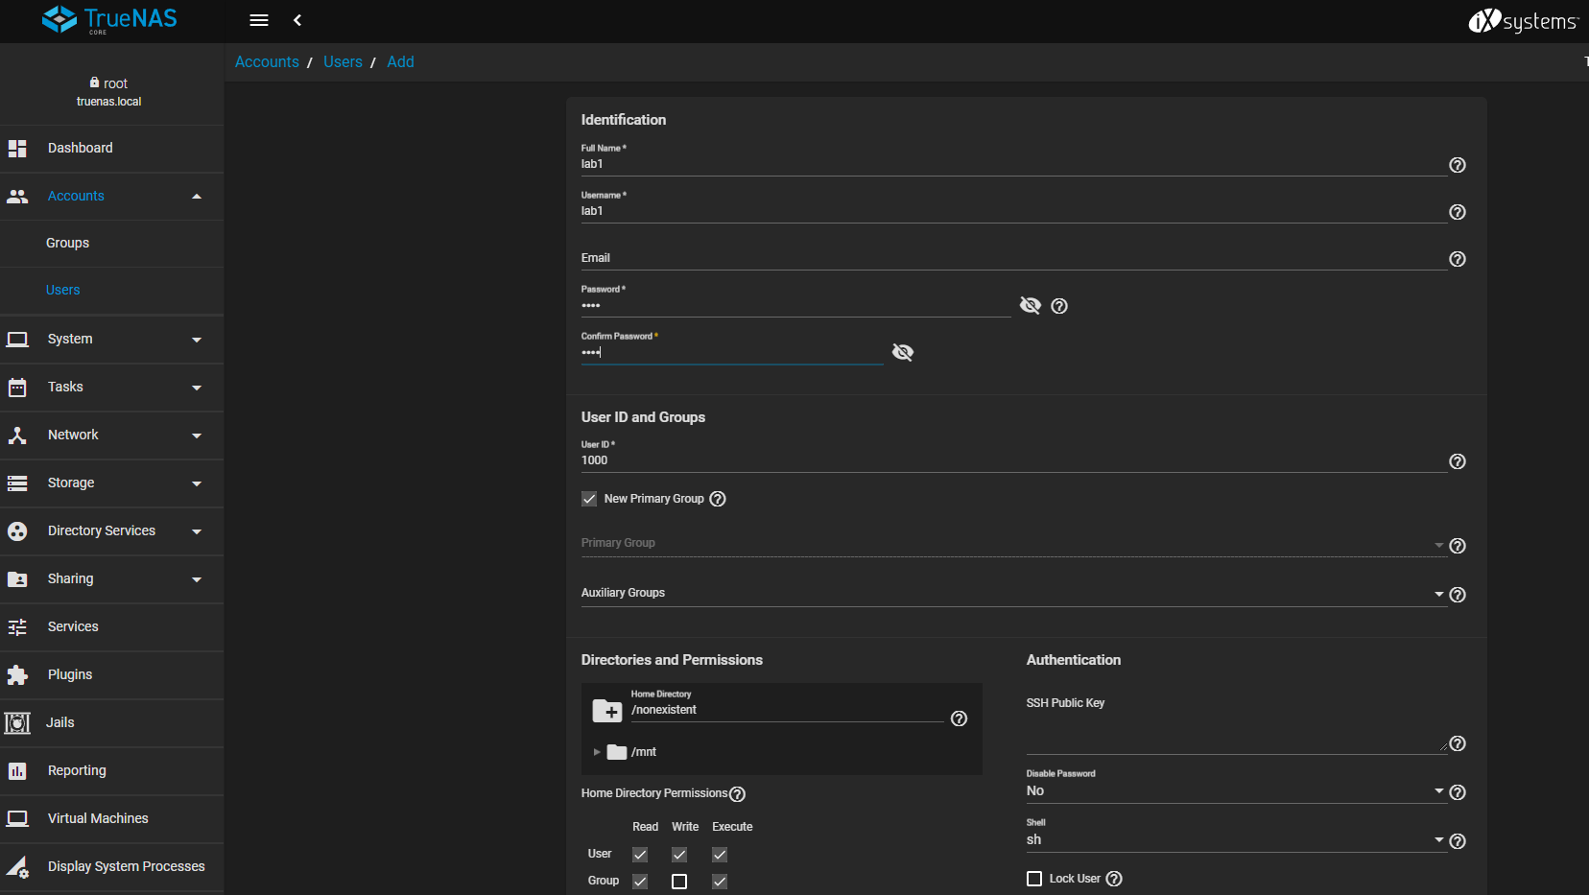

STEP-19 🡺 go to accounts 🡪 users

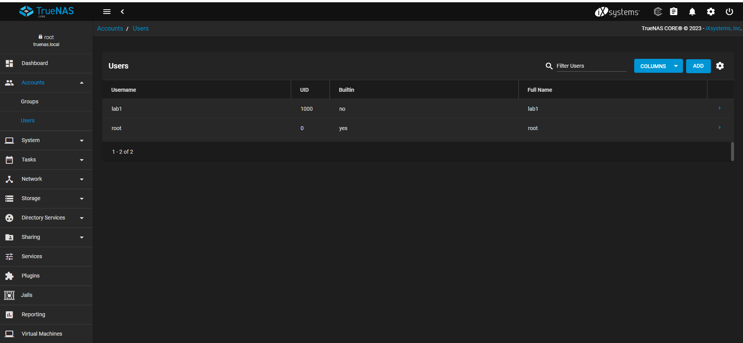

STEP-20 => click on add dataset

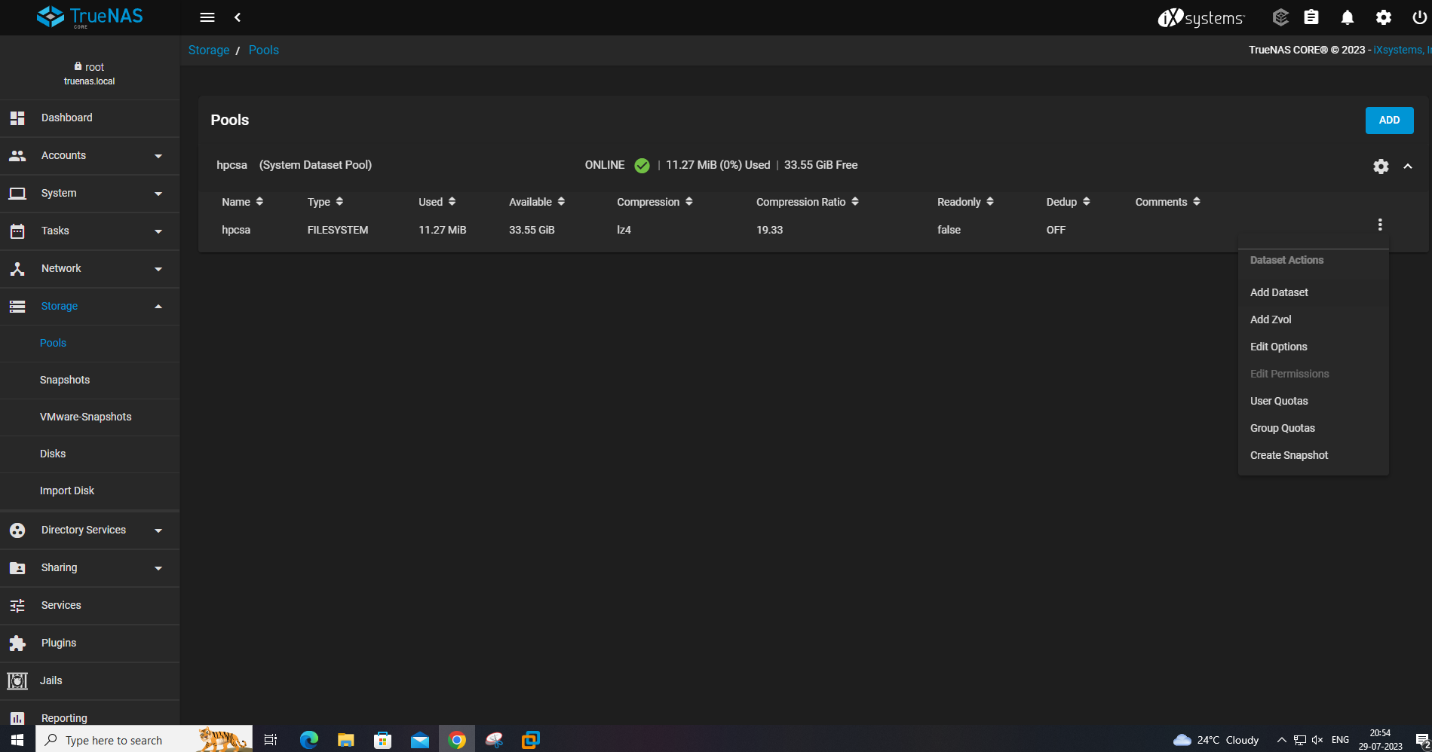

STEP-21 🡺 go to storage 🡪 pool 🡪 add dataset

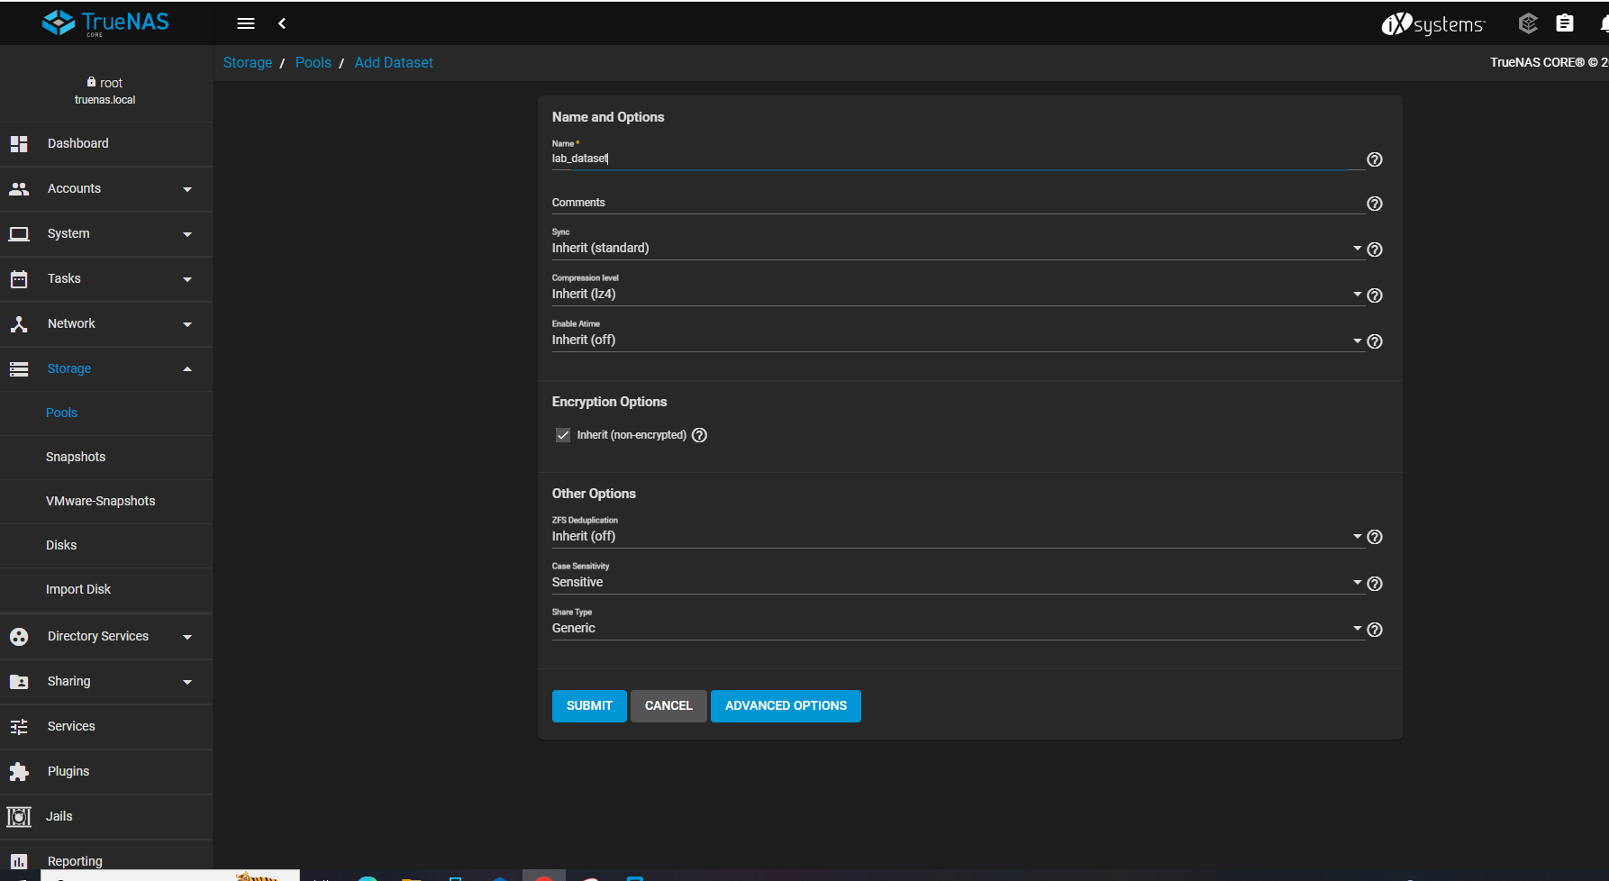

STEP-22

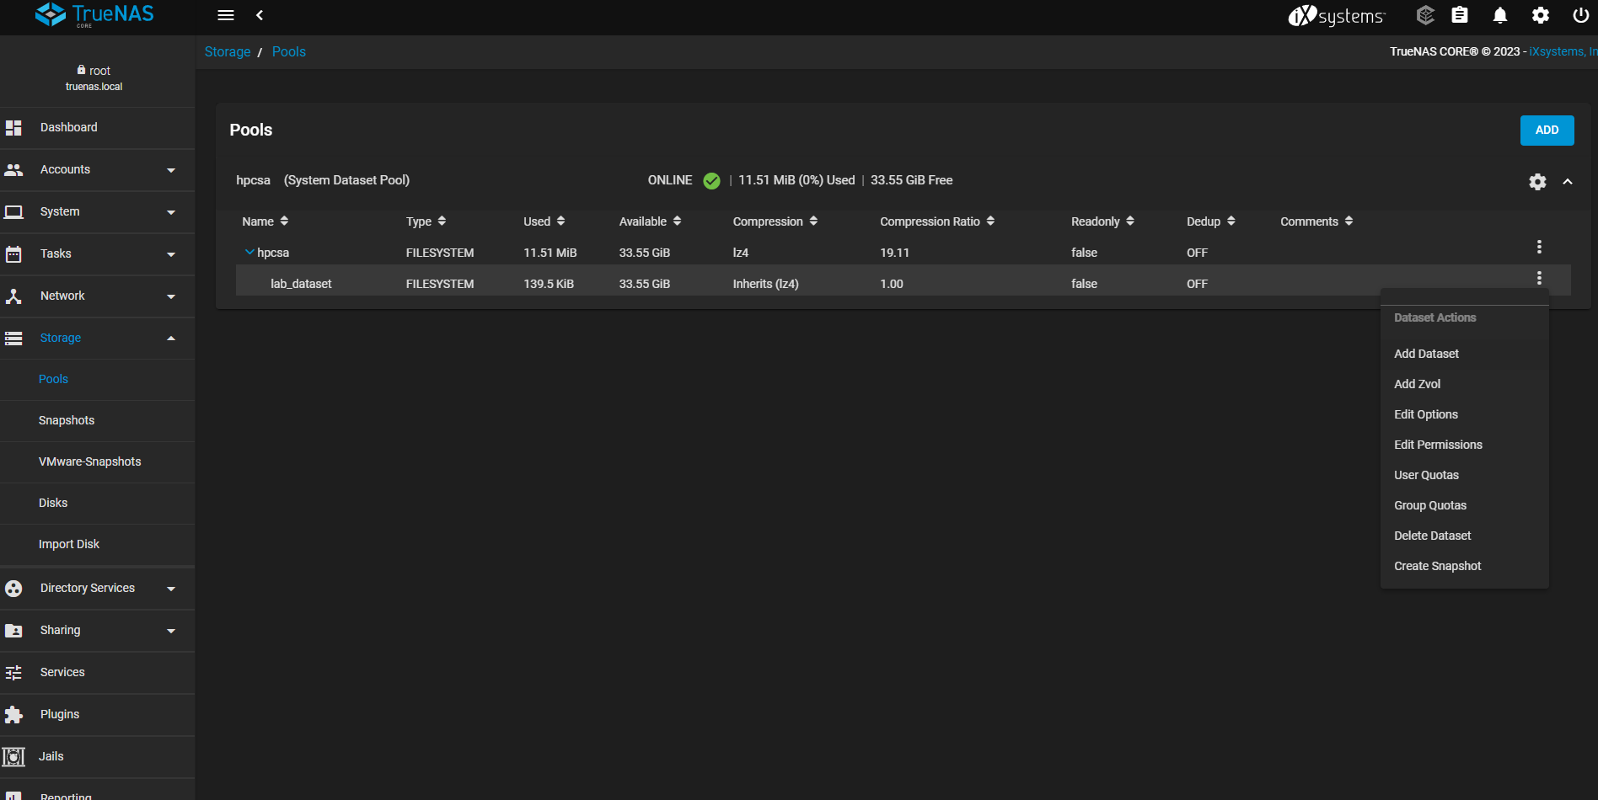

STEP-23

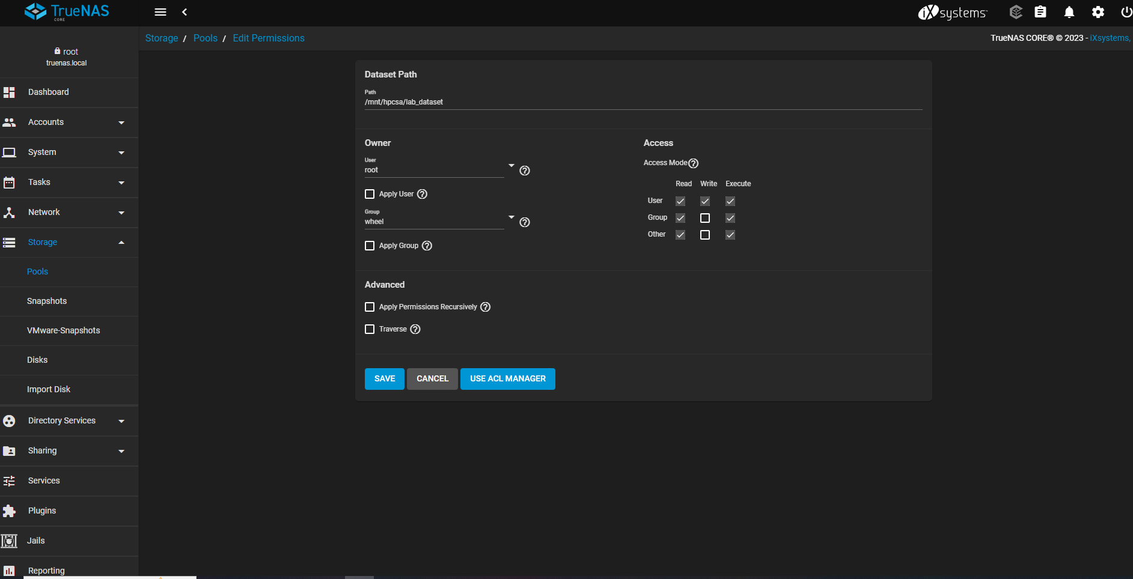

STEP-24 🡺 go to storage 🡪 pools 🡪 edit permissions 🡪 select apply user and apply group

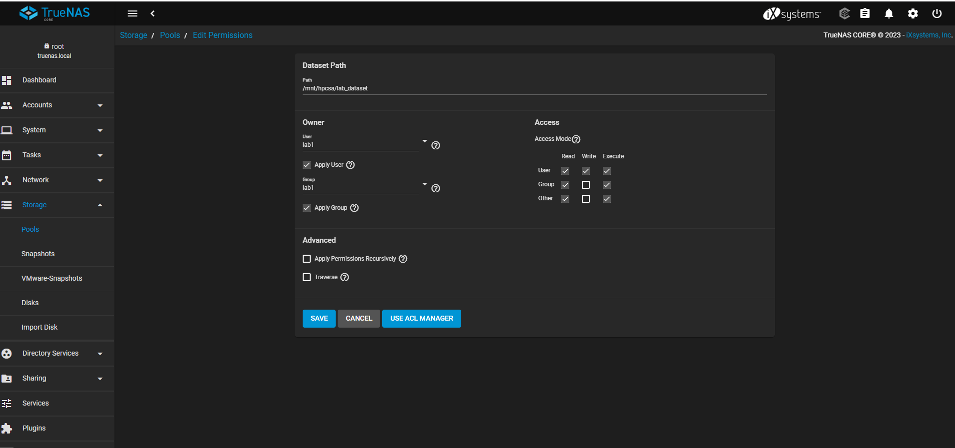

STEP-25

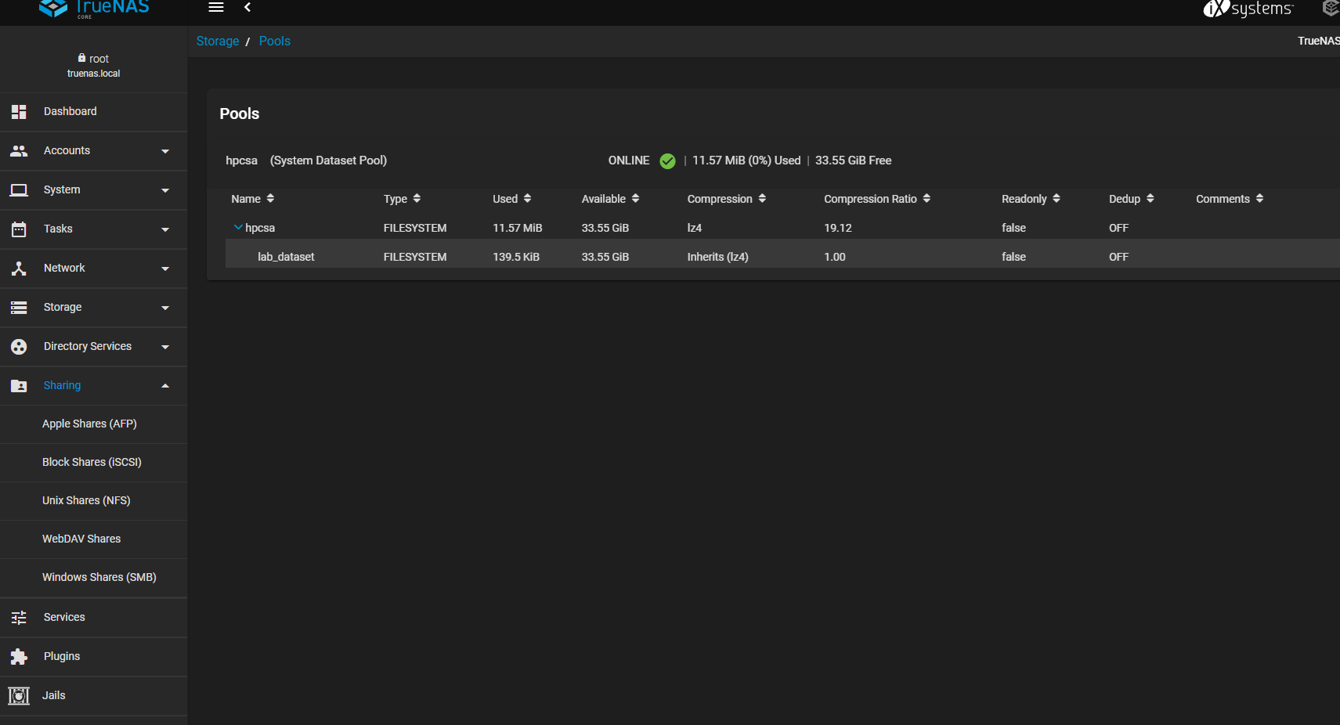

STEP-26 🡺 go to sharing 🡪 window shares(SBM)

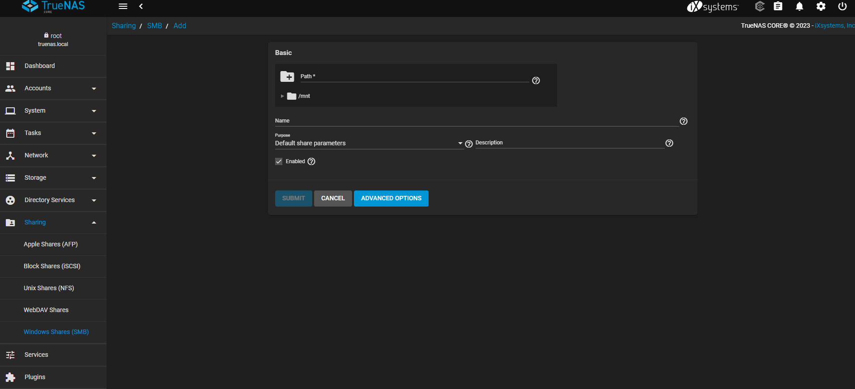

STEP-27 🡺 go to sharing 🡪 window shares(SBM) 🡪

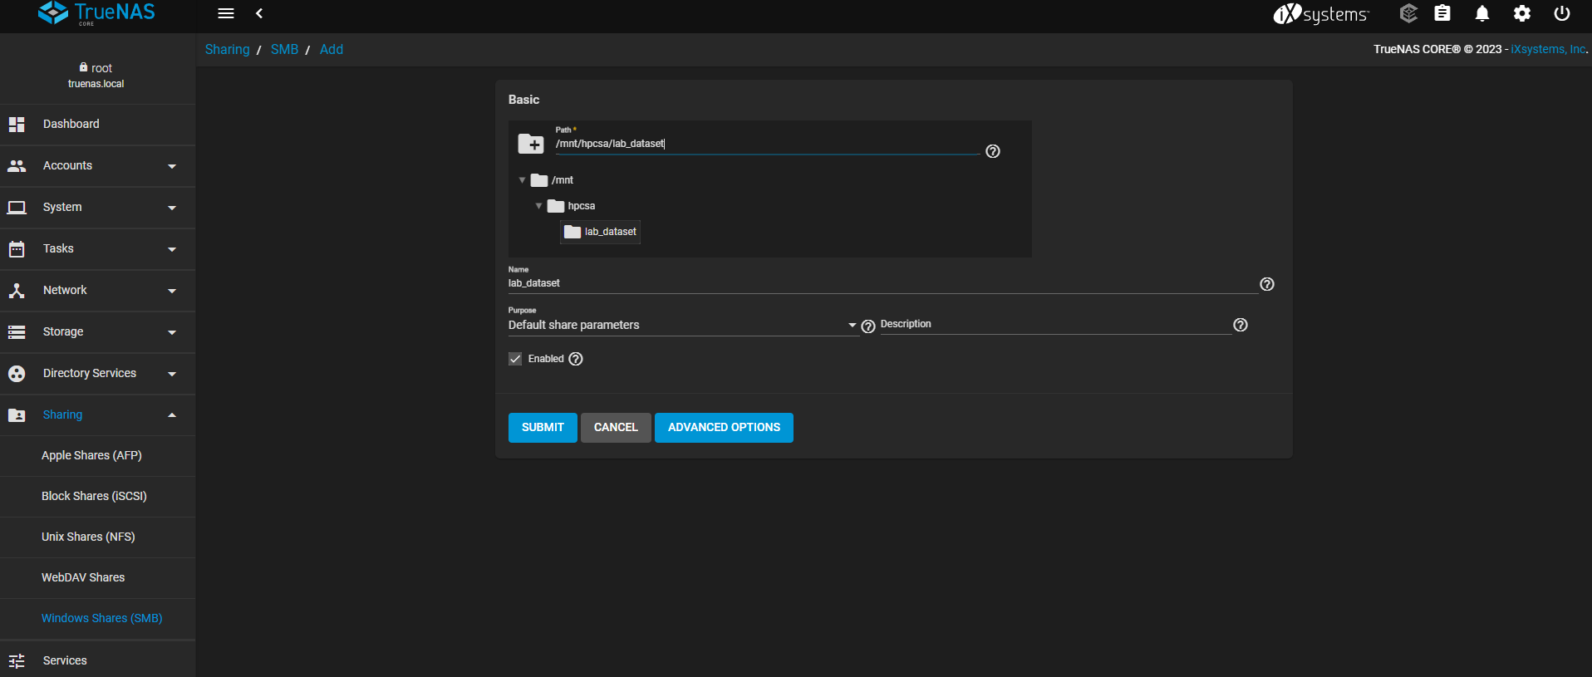

STEP-28 🡺 go to storage 🡪 pools

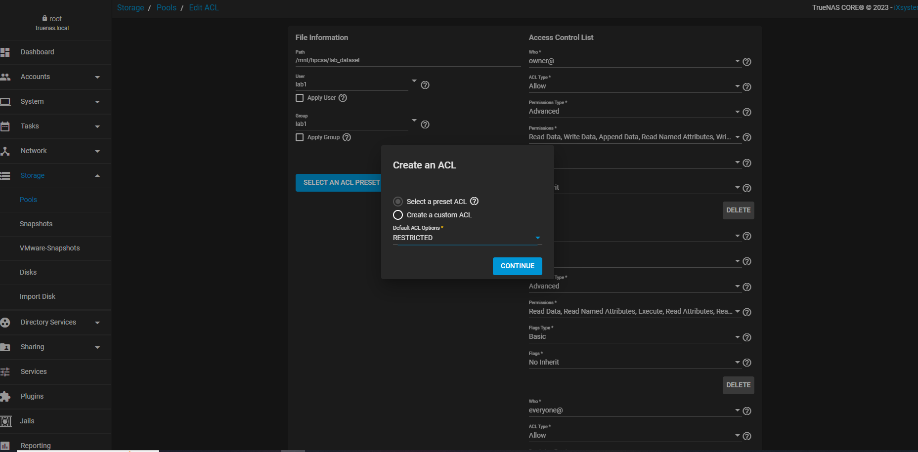

STEP-29 => go to the sharing 🡪 block shares 🡪 target global configuration

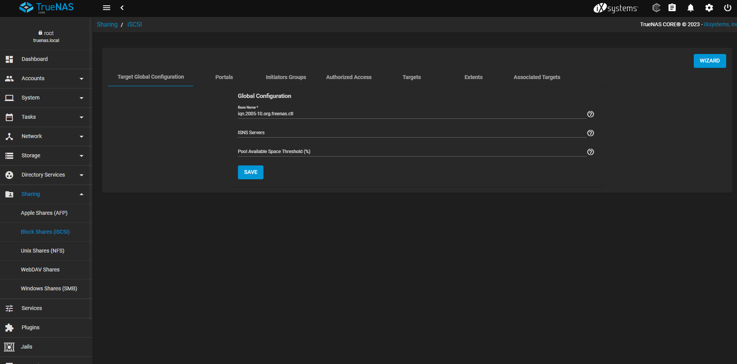

STEP-30 🡺 go to the sharing 🡪 block shares 🡪 portals

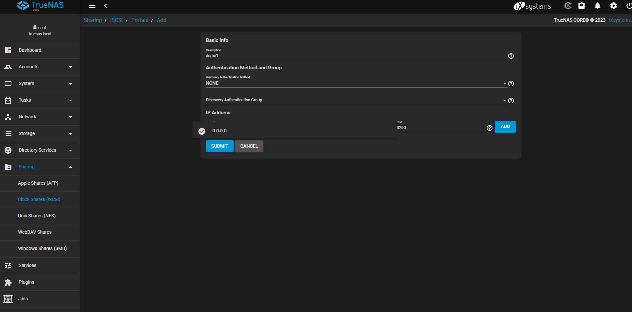

STEP-31

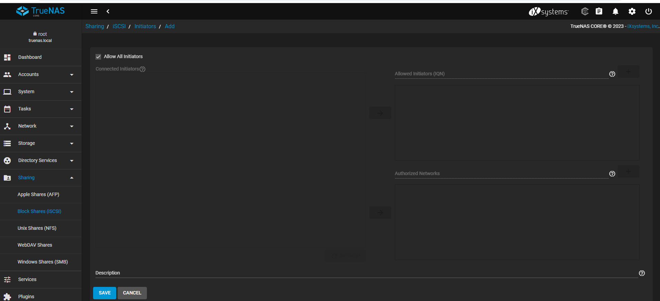

STEP-32 🡺 go to the sharing 🡪 block shares 🡪

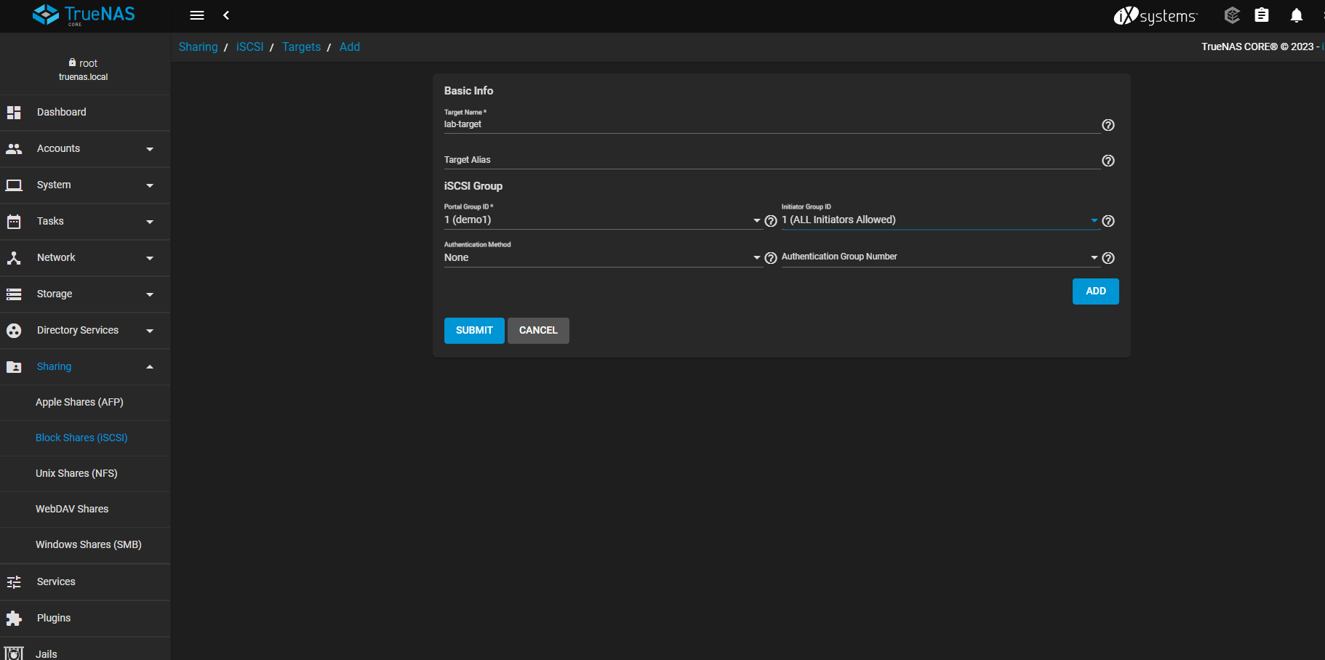

STEP-33 🡺 go to the extent

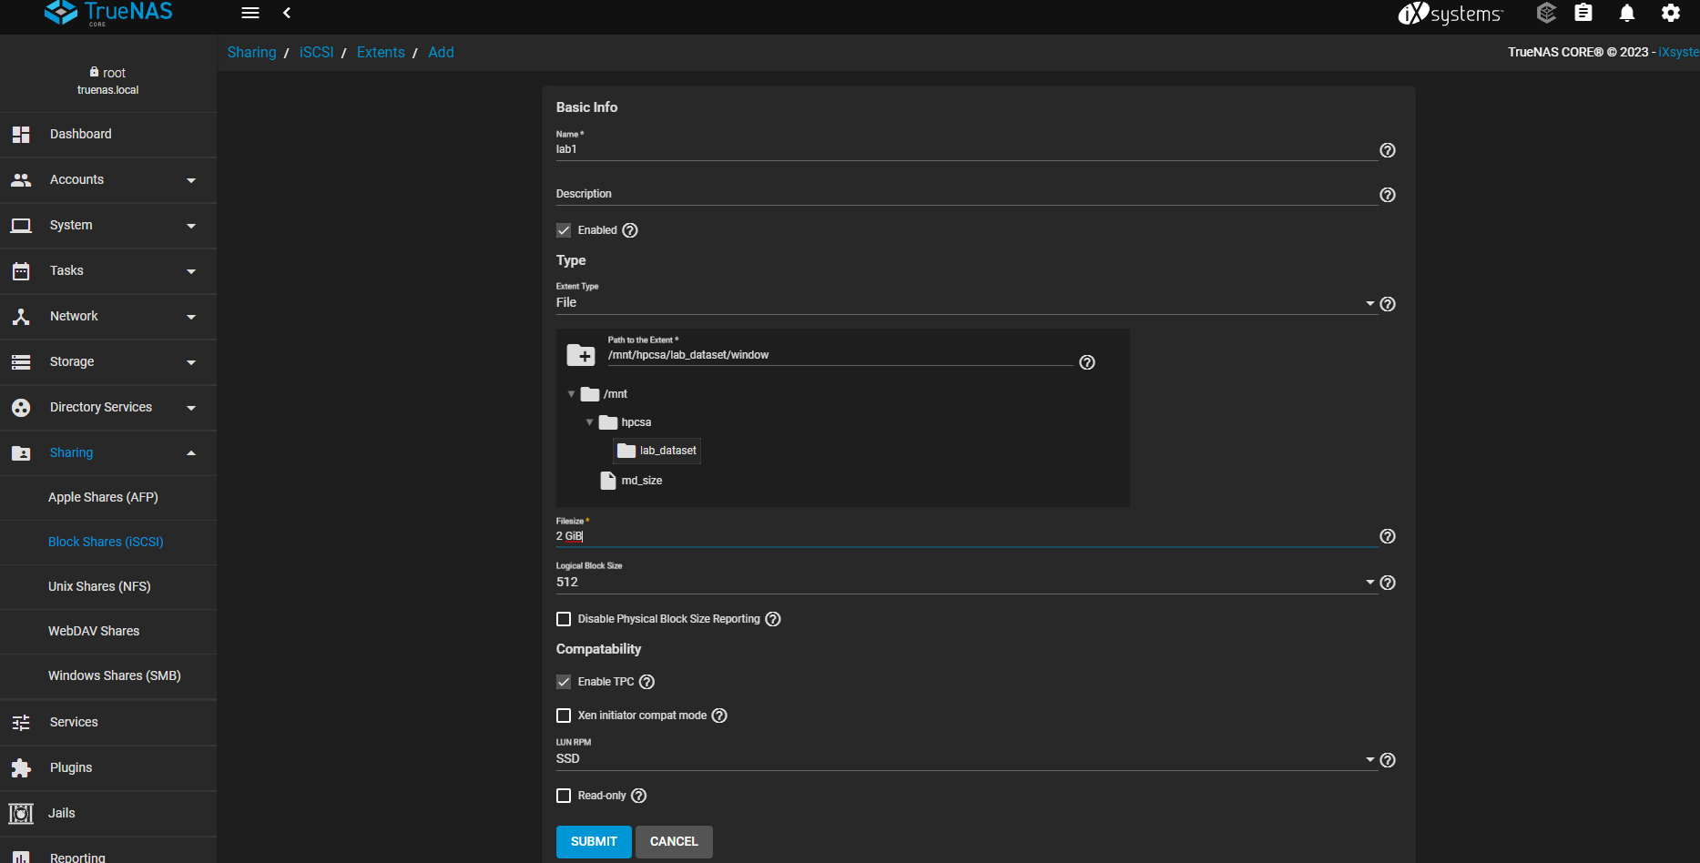

STEP-34 🡺 go to the associated target

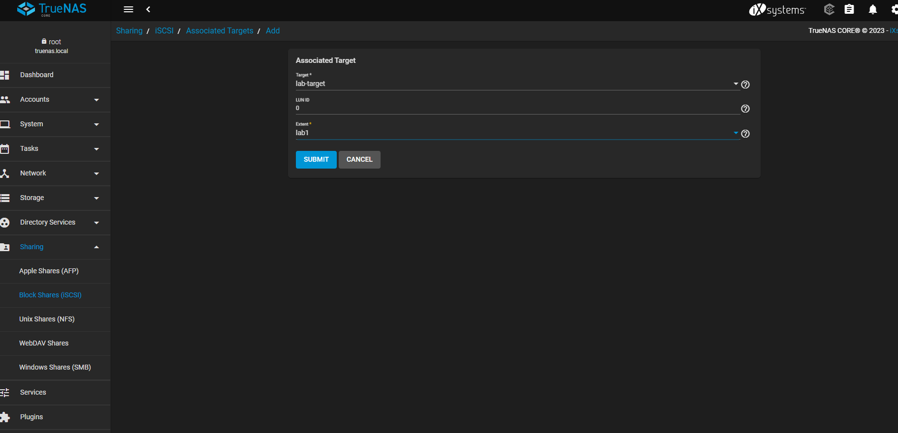

STEP-35 🡺 Go to the services and stop & start the iscsi services

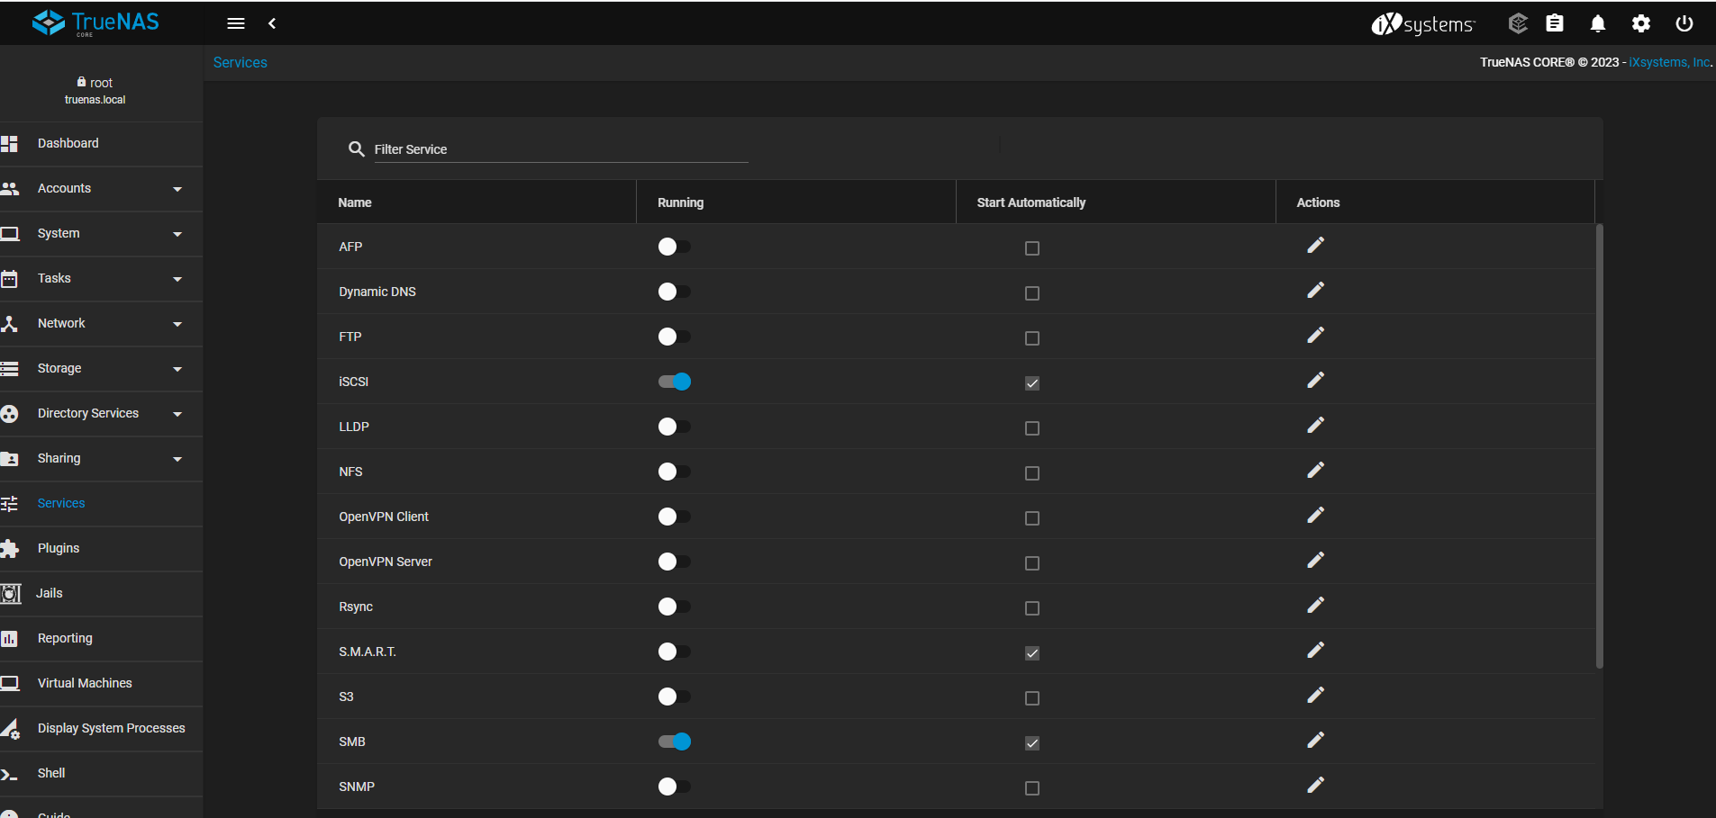

STEP-36 🡺 In the target write the ip of truenas and than click on quick connect

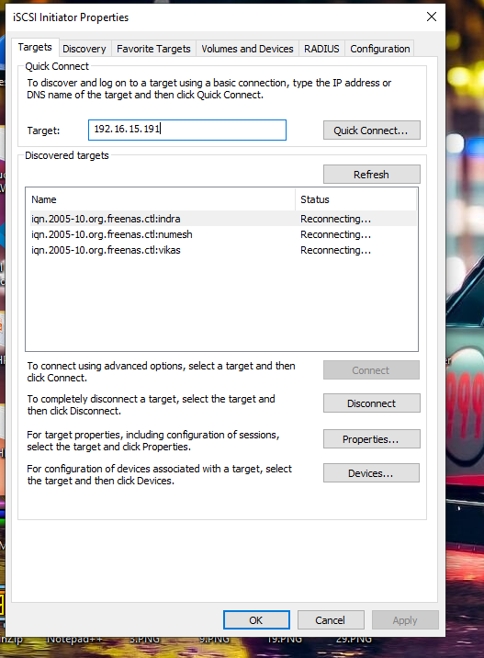

STEP-37

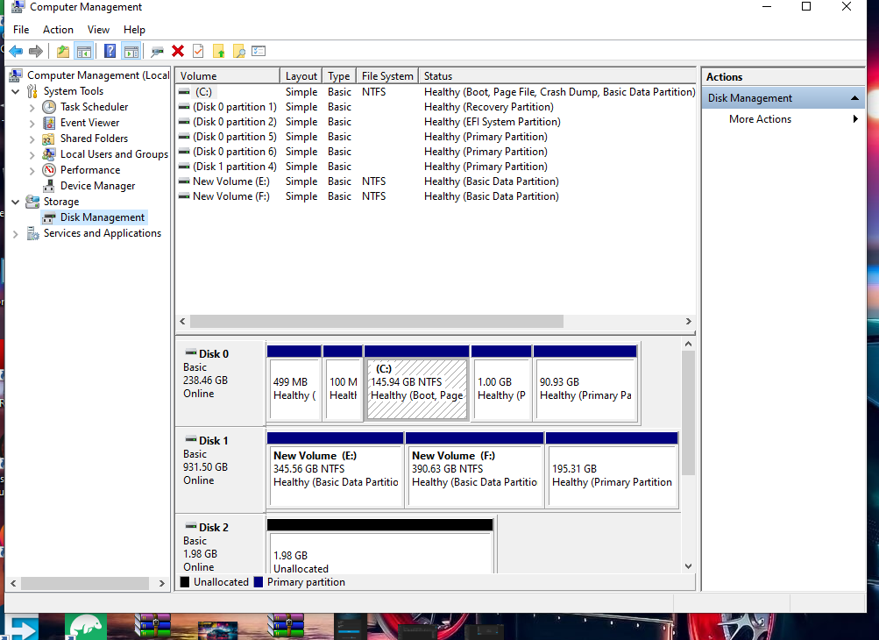

STEP-38 🡺 Go initialize the disk and after that right click and select new simple volume

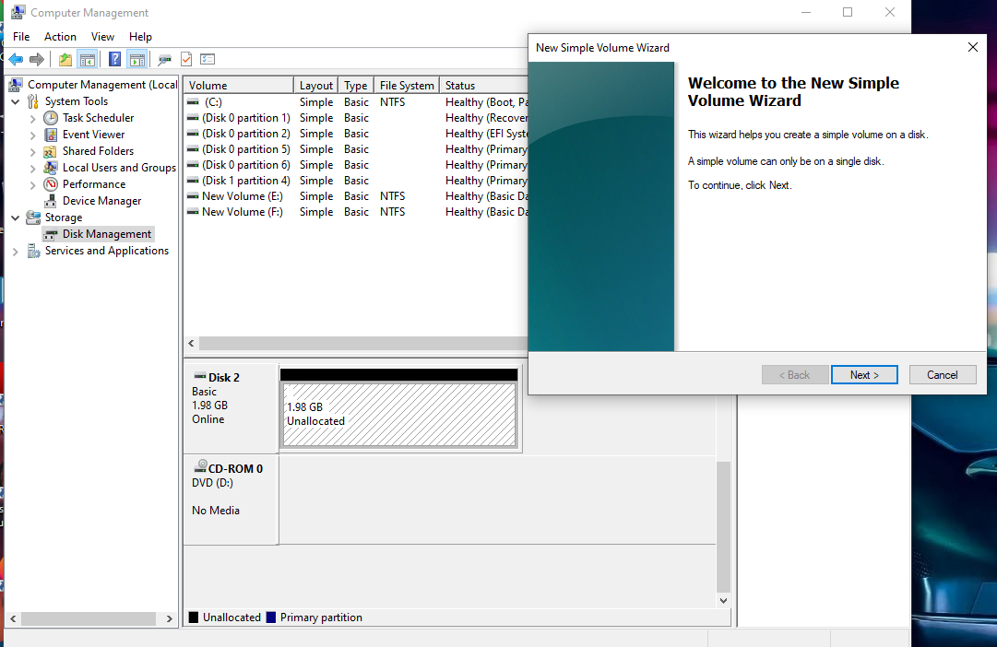

STEP-39 🡺 showing the disk partition of 2GB

